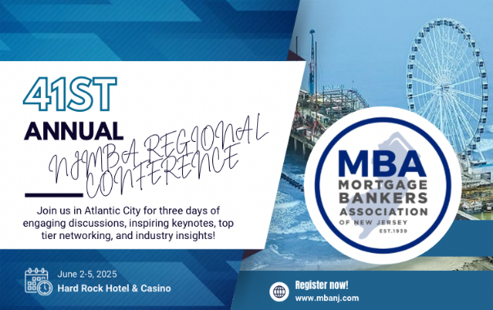

MBA-NJ Charitable Fun Run
In Memory of Regina Lowrie
Benefiting

The MBA Opens Doors Foundation
Join your colleagues at the 41st Regional Conference of MBAs and take part in a fun run in memory of Regina Lowrie, a long-serving Conference Planning Committee member and the first woman to chair the Mortgage Bankers Association.
One of the most trying times in a family's life is when a child is critically ill or has suffered a devastating injury. The toll is both emotional and financial and can force a family to choose between staying with their child in the hospital or going to work to ensure they have a home to go to when the medical nightmare ends.

A family should never have to choose between their child and a housing payment.

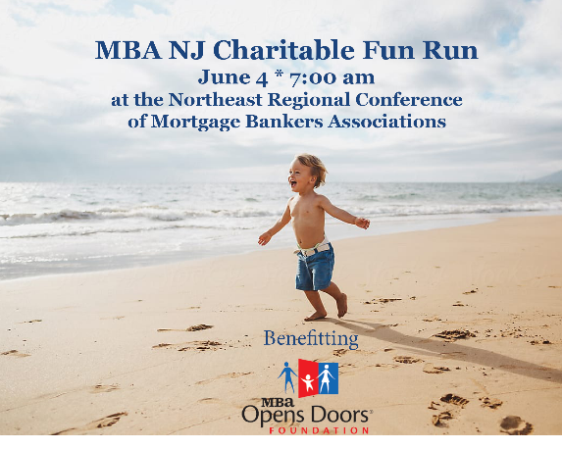
YOU can help!

Scan the QR code and take part in the MBA-NJ Fun Run at 7:00 am on June 4th! $25 gets you entry to the Fun Run and a raffle ticket to win a basket of tasty treats!

Funds raised will go to the MBA Opens Doors Foundation, one of the country’s leading charities in providing mortgage and rental payment assistance to families with a critically ill or injured child.

Join us and help keep a family caring for a
critically ill or injured child in their home.
https://give.mbaopensdoors.org/MBANJ2025

For more information or to get involved, please contact:
Mary Bulman  Regional Account Manager  Towne Mortgage Company  mbulman@townemortgage.com | Deborah Dubois  President  MBA Opens Doors Foundation  ddubois@mba.org
SPONSORSHIP
Corporate Sponsorship Level  Donor Benefits | Platinum  Champion  $5,000+ | Gold  Champion  $2,500+ | Silver  Champion  $1,500+ | Family  Champion  $750+
Custom Recognition
MBA Opens Doors Foundation video with support recognition slide with company logo | 
Event Promotion
Company signage at the starting line and finishing line
Company logo or donor name on signage at mile 1 and mile 2
Company sponsorship of the Fun Run Water Station
Company “motivational” signage along the Fun Run route
Company or Individual registration table top sign
Digital and Online Marketing
Company logo or personal representation and special placement on MBA Opens Doors Foundation Website
Company name on MBA Opens Doors Foundation Website

The MBA Opens Doors Foundation provides the comforts of home to families in crisis. Since 2011, more than 16,000 families across the country have received mortgage and rental assistance grants through the Foundation’s Home Grant Program. And, because the Mortgage Bankers Association pays 100% of the Foundation’s operational expenses, 100% of every dollar raised goes to a family in need. *Signage creation is the responsibility of the donor. Questions? Contact Mary Bulman at mbulman@townemortgage.com

Visit www.mbaopensdoors.org to learn more.

